Fishery Manuscript No. 21-XX

Southeast Alaska Pink Salmon Forecasting Models

by

Sara E. Miller,

James M. Murphy,

Richard E. Brenner,

Emily A. Fergusson,

Steven C. Heinl,

Jamal H. Moss,

Andrew W. Piston,

and

Wesley W. Strasburger

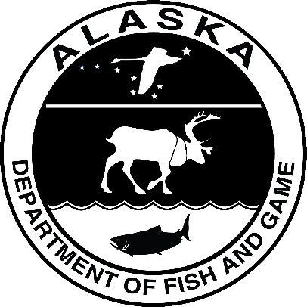

Month 2021

Alaska Department of Fish and Game Divisions of Sport Fish and Commercial Fisheries

Symbols and Abbreviations

The following symbols and abbreviations, and others approved for the Système International d'Unités (SI), are used without definition in the following reports by the Divisions of Sport Fish and of Commercial Fisheries: Fishery Manuscripts, Fishery Data Series Reports, Fishery Management Reports, and Special Publications. All others, including deviations from definitions listed below, are noted in the text at first mention, as well as in the titles or footnotes of tables, and in figure or figure captions.

**Weights and measures (metric)**

centimeter cm

deciliter dL

gram g

hectare ha

kilogram kg

kilometer km

liter L

meter m

milliliter mL

millimeter mm

**Weights and measures (English)**

cubic feet per second ft3/s

foot ft

gallon gal

inch in

mile mi

nautical mile nmi

ounce oz

pound lb

quart qt

yard yd

**Time and temperature**

day d

degrees Celsius °C

degrees Fahrenheit °F

degrees kelvin K

hour h

minute min

second s

**Physics and chemistry**

all atomic symbols

alternating current AC

ampere A

calorie cal

direct current DC

hertz Hz

horsepower hp

hydrogen ion activity pH

(negative log of)

parts per million ppm

parts per thousand ppt,

‰

volts V

watts W

**General**

Alaska Administrative

Code AAC

all commonly accepted

abbreviations e.g., Mr., Mrs., AM, PM, etc.

all commonly accepted

professional titles e.g., Dr., Ph.D.,

R.N., etc.

at @

compass directions:

east E

north N

south S

west W

copyright ©

corporate suffixes:

Company Co.

Corporation Corp.

Incorporated Inc.

Limited Ltd.

District of Columbia D.C.

et alii (and others) et al.

et cetera (and so forth) etc.

exempli gratia

(for example) e.g.

Federal Information

Code FIC

id est (that is) i.e.

latitude or longitude lat or long

monetary symbols

(U.S.) $, ¢

months (tables and

figures): first three

letters Jan,...,Dec

registered trademark ®

trademark ™

United States

(adjective) U.S.

United States of

America (noun) USA

U.S.C. United States Code

U.S. state use two-letter abbreviations (e.g., AK, WA)

**Mathematics, statistics**

*all standard mathematical*

*signs, symbols and*

*abbreviations*

alternate hypothesis HA

base of natural logarithm *e*

catch per unit effort CPUE

coefficient of variation CV

common test statistics (F, t, χ2, etc.)

confidence interval CI

correlation coefficient

(multiple) R

correlation coefficient

(simple) r

covariance cov

degree (angular) °

degrees of freedom df

expected value *E*

greater than >

greater than or equal to ≥

harvest per unit effort HPUE

less than <

less than or equal to ≤

logarithm (natural) ln

logarithm (base 10) log

logarithm (specify base) log2, etc.

minute (angular) '

not significant NS

null hypothesis HO

percent %

probability P

probability of a type I error

(rejection of the null

hypothesis when true) α

probability of a type II error

(acceptance of the null

hypothesis when false) β

second (angular) ″

standard deviation SD

standard error SE

variance

population Var

sample var

fishery manuscript no. 21-XX

Type report title here

by

Sara E. Miller and Richard E. Brenner Alaska Department of Fish and Game, Division of Commercial Fisheries, Juneau

Jamal H. Moss, James M. Murphy, Emily A. Fergusson, and Wesley W. Strasburger*,*National Marine Fisheries Service, Alaska Fisheries Science Center 17109 Point Lena Loop Road, Juneau, AK 99801 USA

and

Steven C. Heinl and Andrew W. Piston Alaska Department of Fish and Game, Division of Commercial Fisheries, Ketchikan

**Delete funding block if not applicable:** This investigation was partially financed by the Federal Aid in Sport Fish Restoration Act (16 U.S.C.777-777K) under Project F-10-XX, Job No. X-X.

Alaska Department of Fish and Game  
Division of Sport Fish, Research and Technical Services  
333 Raspberry Road, Anchorage, Alaska, 99518-1565

Month Year

The Fishery Manuscript Series was established in 1987 by the Division of Sport Fish for the publication of technically oriented results of several years’ work undertaken on a project to address common objectives, provide an overview of work undertaken through multiple projects to address specific research or management goal(s), or new and/or highly technical methods, and became a joint divisional series in 2004 with the Division of Commercial Fisheries. Fishery Manuscripts are intended for fishery and other technical professionals. Fishery Manuscripts are available through the Alaska State Library and on the Internet: <http://www.adfg.alaska.gov/sf/publications/>. This publication has undergone editorial and peer review.

Product names used in this publication are included for completeness and do not constitute product endorsement. The Alaska Department of Fish and Game does not endorse or recommend any specific company or their products.

Author Name,

Alaska Department of Fish and Game, Division of Sport Fish,

Address, USA

Coauthor,

Alaska Department of Fish and Game, Division of Sport Fish

Address, USA

and

Coauthor

Alaska Department of Fish and Game, Division of Sport Fish,

Address, USA

This document should be cited as follows:

Author name, last first, initials, coauthor, initials, last name. Year. Report title. Alaska Department of Fish and Game, Fishery Manuscript No. 21-XX, Anchorage.

The Alaska Department of Fish and Game (ADF&G) administers all programs and activities free from discrimination based on race, color, national origin, age, sex, religion, marital status, pregnancy, parenthood, or disability. The department administers all programs and activities in compliance with Title VI of the Civil Rights Act of 1964, Section 504 of the Rehabilitation Act of 1973, Title II of the Americans with Disabilities Act (ADA) of 1990, the Age Discrimination Act of 1975, and Title IX of the Education Amendments of 1972.

**If you believe you have been discriminated against in any program, activity, or facility please write:**

ADF&G ADA Coordinator, P.O. Box 115526, Juneau, AK 99811-5526

U.S. Fish and Wildlife Service, 4401 N. Fairfax Drive, MS 2042, Arlington, VA 22203

Office of Equal Opportunity, U.S. Department of the Interior, 1849 C Street NW MS 5230, Washington DC 20240

**The department’s ADA Coordinator can be reached via phone at the following numbers:**

(VOICE) 907-465-6077, (Statewide Telecommunication Device for the Deaf) 1-800-478-3648,

(Juneau TDD) 907-465-3646, or (FAX) 907-465-6078

**For information on alternative formats and questions on this publication, please contact:**

ADF&G Division of Sport Fish, Research and Technical Services, 333 Raspberry Road, Anchorage AK 99518 (907) 267-2375

TABLE OF CONTENTS

Page

LIST OF TABLES i

LIST OF FIGURES i

LIST OF APPENDICES i

# LIST OF TABLES

Table Page

# LIST OF FIGURES

Figure Page

# LIST OF APPENDICES

Appendix Page

# abstract

# introduction

# Objectives

# Methods

## Satellite-derived SST data

Satellite-derived sea surface temperature (SST) data from April 1997 through June 2021 were pulled from the ‘SST and SST Anomaly, NOAA Global Coral Bleaching Monitoring, 5km, V.3.1, Monthly, 1985-Present’ time series. The monthly data for July 2021 from the site was not available at the time of the assessment, so the daily data was summarized by month and region, and then combined with the monthly data from April 1997 through June 2021 to create the SST dataset (April 1997 through July 2021). This satellite-derived SST data set was then matched to pre-determined coordinates from four spatial regions that corresponded with sixteen variables of interest (four regions; four temporal variables per region).

### Satellite-derived SST variables

**Icy_Strait_SST_May**: The Icy Strait region encompasses waters of Icy Strait from the east end of Lemesurier Island to a line from Point Couverden south to Point Augusta. This variable is the average SST in May (Table 1; Figure 1; Figure 5a).

**Icy_Strait_SST_MJJ**: The Icy Strait region encompasses waters of Icy Strait from the east end of Lemesurier Island to a line from Point Couverden south to Point Augusta. This variable is the average SST in May through July (Table 1; Figure 1; Figure 5b).

**Icy_Strait_SST_AMJ**: The Icy Strait region encompasses waters of Icy Strait from the east end of Lemesurier Island to a line from Point Couverden south to Point Augusta. This variable is the average SST in April through June (Table 1; Figure 1; Figure 5c).

**Icy_Strait_SST_AMJJ**: The Icy Strait region encompasses waters of Icy Strait from the east end of Lemesurier Island to a line from Point Couverden south to Point Augusta. This variable is the average SST in April through July (Table 1; Figure 1; Figure 5d).

**Chatham_SST_May**: The Chatham and Icy Straits region encompasses waters of Chatham and Icy Straits east of Lemesurier Island to Point Couverden, and south to the approximate latitude of 56.025 degrees north (roughly Cape Decision off Kuiu Island) (Figure 2 and Figure 5a; Table 2). This variable is the average SST in May.

**Chatham_SST_MJJ**: The Chatham and Icy Straits region encompasses waters of Chatham and Icy Straits east of Lemesurier Island to Point Couverden, south to the approximate latitude of 56.025 degrees north (roughly Cape Decision off Kuiu Island) (Figure 2 and Figure 5b; Table 2). This variable is the average SST in May through July.

**Chatham_SST_AMJ**: The Chatham and Icy Straits region encompasses waters of Chatham and Icy Straits east of Lemesurier Island to Point Couverden, south to the approximate latitude of 56.025 degrees north (roughly Cape Decision off Kuiu Island) (Figure 2 and Figure 5c; Table 2). This variable is the average SST in April through June.

**Chatham_SST_AMJJ**: The Chatham and Icy Straits region encompasses waters of Chatham and Icy Straits east of Lemesurier Island to Point Couverden, south to the approximate latitude of 56.025 degrees north (roughly Cape Decision off Kuiu Island) (Figure 2 and Figure 5d; Table 2). This variable is the average SST in April through July.

**NSEAK_SST_May**: The NSEAK region encompasses northern Southeast Alaska from 59.475 to 56.075 degrees north latitude (approximately Districts 9 through 15, and District 13 inside area only; northern Southeast Inside subregion for Southeast Alaska (NSEI); Figure 3 and Figure 5a; Table 3). This variable is the average SST in May.

**NSEAK_SST_MJJ**: The NSEAK region encompasses northern Southeast Alaska from 59.475 to 56.075 degrees north latitude (approximately Districts 9 through 15, and District 13 inside area only; northern Southeast Inside subregion for Southeast Alaska (NSEI); Figure 3 and Figure 5b; Table 3). This variable is the average SST in May through July.

**NSEAK_SST_AMJ**: The NSEAK region encompasses northern Southeast Alaska from 59.475 to 56.075 degrees north latitude (approximately Districts 9 through 15, and District 13 inside area only; northern Southeast Inside subregion for Southeast Alaska (NSEI); Figure 3 and Figure 5c; Table 3). This variable is the average SST in April through June.

**NSEAK_SST_AMJJ**: The NSEAK region encompasses northern Southeast Alaska from 59.475 to 56.075 degrees north latitude (approximately Districts 9 through 15, and District 13 inside area only; northern Southeast Inside subregion for Southeast Alaska (NSEI); Figure 3 and Figure 5d; Table 3). This variable is the average SST in April through July.

**SEAK_SST_May**: The SEAK region encompasses Southeast Alaska from 59.475 to 54.725 degrees north latitude (Figure 4 and Figure 5a; Table 4). This variable is the average SST in May.

**SEAK_SST_MJJ**: The SEAK region encompasses northern Southeast Alaska from 59.475 to 54.725 degrees north latitude (Figure 4 and Figure 5b; Table 4). This variable is the average SST in May through July.

**SEAK_SST_AMJ**: The SEAK region encompasses Southeast Alaska from 59.475 to 54.725 degrees north latitude (Figure 4 and Figure 5c; Table 4). This variable is the average SST in April through June.

**SEAK_SST_AMJJ**: The SEAK region encompasses Southeast Alaska from 59.475 to 54.725 degrees north latitude (Figure 4 and Figure 5d; Table 4). This variable is the average SST in April through July.

#### Summarized data

Satellite sea surface temperature data were summarized by region and year (i.e., average of May (May), the average over the months of May, June, and July (MJJ), the average over the months of April through June (AMJ), or the average over the months of April through July (AMJJ)) from 1997 to 2021 (Tables 1 through 4).

Table 1.–Satellite sea temperature data from the Icy Strait region from 1997 to 2021 for the month of May (May), May through July (MJJ), April through June (AMJ), and April through July (AMJJ). There are 70 satellite stations (latitude/longitude combinations) in the Icy Strait region.

|  |  |  |  |  |
| --- | --- | --- | --- | --- |
| year | Icy_Strait_SST_MJJ | Icy_Strait_SST_May | Icy_Strait_SST_AMJJ | Icy_Strait_SST_AMJ |
| 1997 | 10.30 | 7.01 | 8.83 | 7.30 |
| 1998 | 9.97 | 7.34 | 8.85 | 7.56 |
| 1999 | 9.08 | 6.17 | 8.02 | 6.78 |
| 2000 | 9.94 | 7.02 | 8.67 | 7.35 |
| 2001 | 9.57 | 6.48 | 8.40 | 7.08 |
| 2002 | 9.34 | 6.26 | 8.02 | 6.60 |
| 2003 | 10.08 | 7.29 | 8.88 | 7.53 |
| 2004 | 10.68 | 7.53 | 9.25 | 7.69 |
| 2005 | 11.16 | 8.40 | 9.64 | 8.26 |
| 2006 | 10.19 | 6.84 | 8.86 | 7.49 |
| 2007 | 9.49 | 6.55 | 8.16 | 6.87 |
| 2008 | 8.85 | 6.43 | 7.72 | 6.68 |
| 2009 | 9.94 | 7.19 | 8.47 | 7.22 |
| 2010 | 9.87 | 7.71 | 8.68 | 7.81 |
| 2011 | 9.84 | 6.81 | 8.47 | 7.18 |
| 2012 | 9.23 | 6.92 | 8.10 | 7.07 |
| 2013 | 9.88 | 6.37 | 8.45 | 6.97 |
| 2014 | 10.23 | 7.90 | 8.81 | 7.62 |
| 2015 | 10.73 | 8.34 | 9.43 | 8.29 |
| 2016 | 11.65 | 8.81 | 10.37 | 9.14 |
| 2017 | 9.82 | 7.22 | 8.66 | 7.51 |
| 2018 | 9.99 | 6.92 | 8.74 | 7.43 |
| 2019 | 10.74 | 7.79 | 9.51 | 8.10 |
| 2020 | 10.40 | 7.83 | 9.05 | 7.86 |
| 2021 | 10.26 | 6.91 | 8.91 | 7.47 |

Table 2.–Satellite sea temperature data from the Chatham and Icy Straits region from 1997 to 2021 for the month of May (May), May through July (MJJ), April through June (AMJ), and April through July (AMJJ). There are 313 satellite stations (latitude/longitude combinations) in the Chatham and Icy Straits region.

|  |  |  |  |  |
| --- | --- | --- | --- | --- |
| year | Chatham_SST_MJJ | Chatham_SST_May | Chatham_SST_AMJJ | Chatham_SST_AMJ |
| 1997 | 10.08 | 7.48 | 8.83 | 7.59 |
| 1998 | 9.85 | 7.83 | 8.91 | 7.88 |
| 1999 | 8.90 | 6.84 | 8.05 | 7.12 |
| 2000 | 9.70 | 7.34 | 8.62 | 7.52 |
| 2001 | 9.15 | 6.74 | 8.18 | 7.12 |
| 2002 | 8.97 | 6.39 | 7.85 | 6.64 |
| 2003 | 9.92 | 7.71 | 8.90 | 7.85 |
| 2004 | 10.43 | 7.94 | 9.22 | 7.96 |
| 2005 | 10.67 | 8.51 | 9.48 | 8.44 |
| 2006 | 9.78 | 7.16 | 8.68 | 7.58 |
| 2007 | 9.52 | 7.04 | 8.41 | 7.27 |
| 2008 | 8.65 | 6.77 | 7.69 | 6.83 |
| 2009 | 9.75 | 7.30 | 8.46 | 7.35 |
| 2010 | 9.65 | 7.97 | 8.66 | 7.93 |
| 2011 | 9.59 | 7.31 | 8.49 | 7.55 |
| 2012 | 9.17 | 7.07 | 8.18 | 7.22 |
| 2013 | 9.66 | 6.74 | 8.44 | 7.21 |
| 2014 | 9.98 | 8.17 | 8.76 | 7.77 |
| 2015 | 10.62 | 8.87 | 9.55 | 8.73 |
| 2016 | 11.04 | 8.92 | 10.03 | 9.07 |
| 2017 | 9.65 | 7.65 | 8.70 | 7.76 |
| 2018 | 9.87 | 7.40 | 8.75 | 7.61 |
| 2019 | 10.47 | 8.24 | 9.46 | 8.35 |
| 2020 | 9.99 | 8.09 | 8.84 | 7.86 |
| 2021 | 10.06 | 7.25 | 8.90 | 7.63 |

Table 3.–Satellite sea temperature from the northern Southeast Alaska (NSEAK) region from 1997 to 2021 for the month of May (May), May through July (MJJ), April through June (AMJ), and April through July (AMJJ). There are 1,344 satellite stations (latitude/longitude combinations) in the NSEAK region.

|  |  |  |  |  |
| --- | --- | --- | --- | --- |
| year | NSEAK_SST_MJJ | NSEAK_SST_May | NSEAK_SST_AMJJ | NSEAK_SST_AMJ |
| 1997 | 10.02 | 7.35 | 8.71 | 7.40 |
| 1998 | 9.89 | 7.65 | 8.85 | 7.71 |
| 1999 | 8.93 | 6.70 | 7.98 | 6.95 |
| 2000 | 9.70 | 7.23 | 8.57 | 7.39 |
| 2001 | 9.22 | 6.66 | 8.17 | 7.01 |
| 2002 | 9.05 | 6.39 | 7.88 | 6.61 |
| 2003 | 9.86 | 7.57 | 8.76 | 7.60 |
| 2004 | 10.38 | 7.89 | 9.09 | 7.79 |
| 2005 | 10.63 | 8.42 | 9.35 | 8.26 |
| 2006 | 9.72 | 6.98 | 8.55 | 7.36 |
| 2007 | 9.44 | 6.90 | 8.24 | 7.03 |
| 2008 | 8.65 | 6.64 | 7.63 | 6.74 |
| 2009 | 9.77 | 7.32 | 8.40 | 7.24 |
| 2010 | 9.62 | 7.76 | 8.54 | 7.72 |
| 2011 | 9.67 | 7.25 | 8.44 | 7.44 |
| 2012 | 9.14 | 6.95 | 8.09 | 7.10 |
| 2013 | 9.67 | 6.59 | 8.36 | 7.04 |
| 2014 | 10.03 | 8.15 | 8.70 | 7.64 |
| 2015 | 10.81 | 8.92 | 9.56 | 8.65 |
| 2016 | 11.18 | 8.92 | 10.05 | 9.00 |
| 2017 | 9.82 | 7.75 | 8.77 | 7.78 |
| 2018 | 10.11 | 7.53 | 8.86 | 7.63 |
| 2019 | 10.87 | 8.42 | 9.65 | 8.44 |
| 2020 | 10.23 | 8.26 | 8.98 | 7.94 |
| 2021 | 10.23 | 7.29 | 8.96 | 7.65 |

Table 4.–Satellite sea temperature from the Southeast Alaska (SEAK) region from 1997 to 2021 for the month of May (May), May through July (MJJ), April through June (AMJ), and April through July (AMJJ). There are 2,663 satellite stations (latitude/longitude combinations) in the SEAK region.

|  |  |  |  |  |
| --- | --- | --- | --- | --- |
| year | SEAK_SST_MJJ | SEAK_SST_May | SEAK_SST_AMJJ | SEAK_SST_AMJ |
| 1997 | 10.47 | 8.00 | 9.20 | 7.99 |
| 1998 | 10.36 | 8.37 | 9.38 | 8.37 |
| 1999 | 9.30 | 7.23 | 8.40 | 7.43 |
| 2000 | 10.02 | 7.71 | 8.95 | 7.86 |
| 2001 | 9.51 | 7.10 | 8.52 | 7.45 |
| 2002 | 9.44 | 6.92 | 8.33 | 7.14 |
| 2003 | 10.32 | 8.17 | 9.25 | 8.16 |
| 2004 | 10.98 | 8.58 | 9.74 | 8.51 |
| 2005 | 11.06 | 8.92 | 9.83 | 8.82 |
| 2006 | 10.19 | 7.63 | 9.07 | 7.96 |
| 2007 | 9.99 | 7.51 | 8.82 | 7.64 |
| 2008 | 9.18 | 7.22 | 8.17 | 7.28 |
| 2009 | 10.20 | 7.76 | 8.85 | 7.73 |
| 2010 | 10.09 | 8.28 | 9.05 | 8.23 |
| 2011 | 10.05 | 7.74 | 8.88 | 7.92 |
| 2012 | 9.68 | 7.47 | 8.63 | 7.61 |
| 2013 | 10.39 | 7.51 | 9.10 | 7.85 |
| 2014 | 10.57 | 8.62 | 9.26 | 8.17 |
| 2015 | 11.43 | 9.64 | 10.21 | 9.32 |
| 2016 | 11.67 | 9.61 | 10.59 | 9.59 |
| 2017 | 10.31 | 8.25 | 9.28 | 8.29 |
| 2018 | 10.79 | 8.28 | 9.54 | 8.30 |
| 2019 | 11.46 | 9.01 | 10.25 | 9.05 |
| 2020 | 10.70 | 8.90 | 9.52 | 8.53 |
| 2021 | 10.82 | 7.97 | 9.58 | 8.31 |

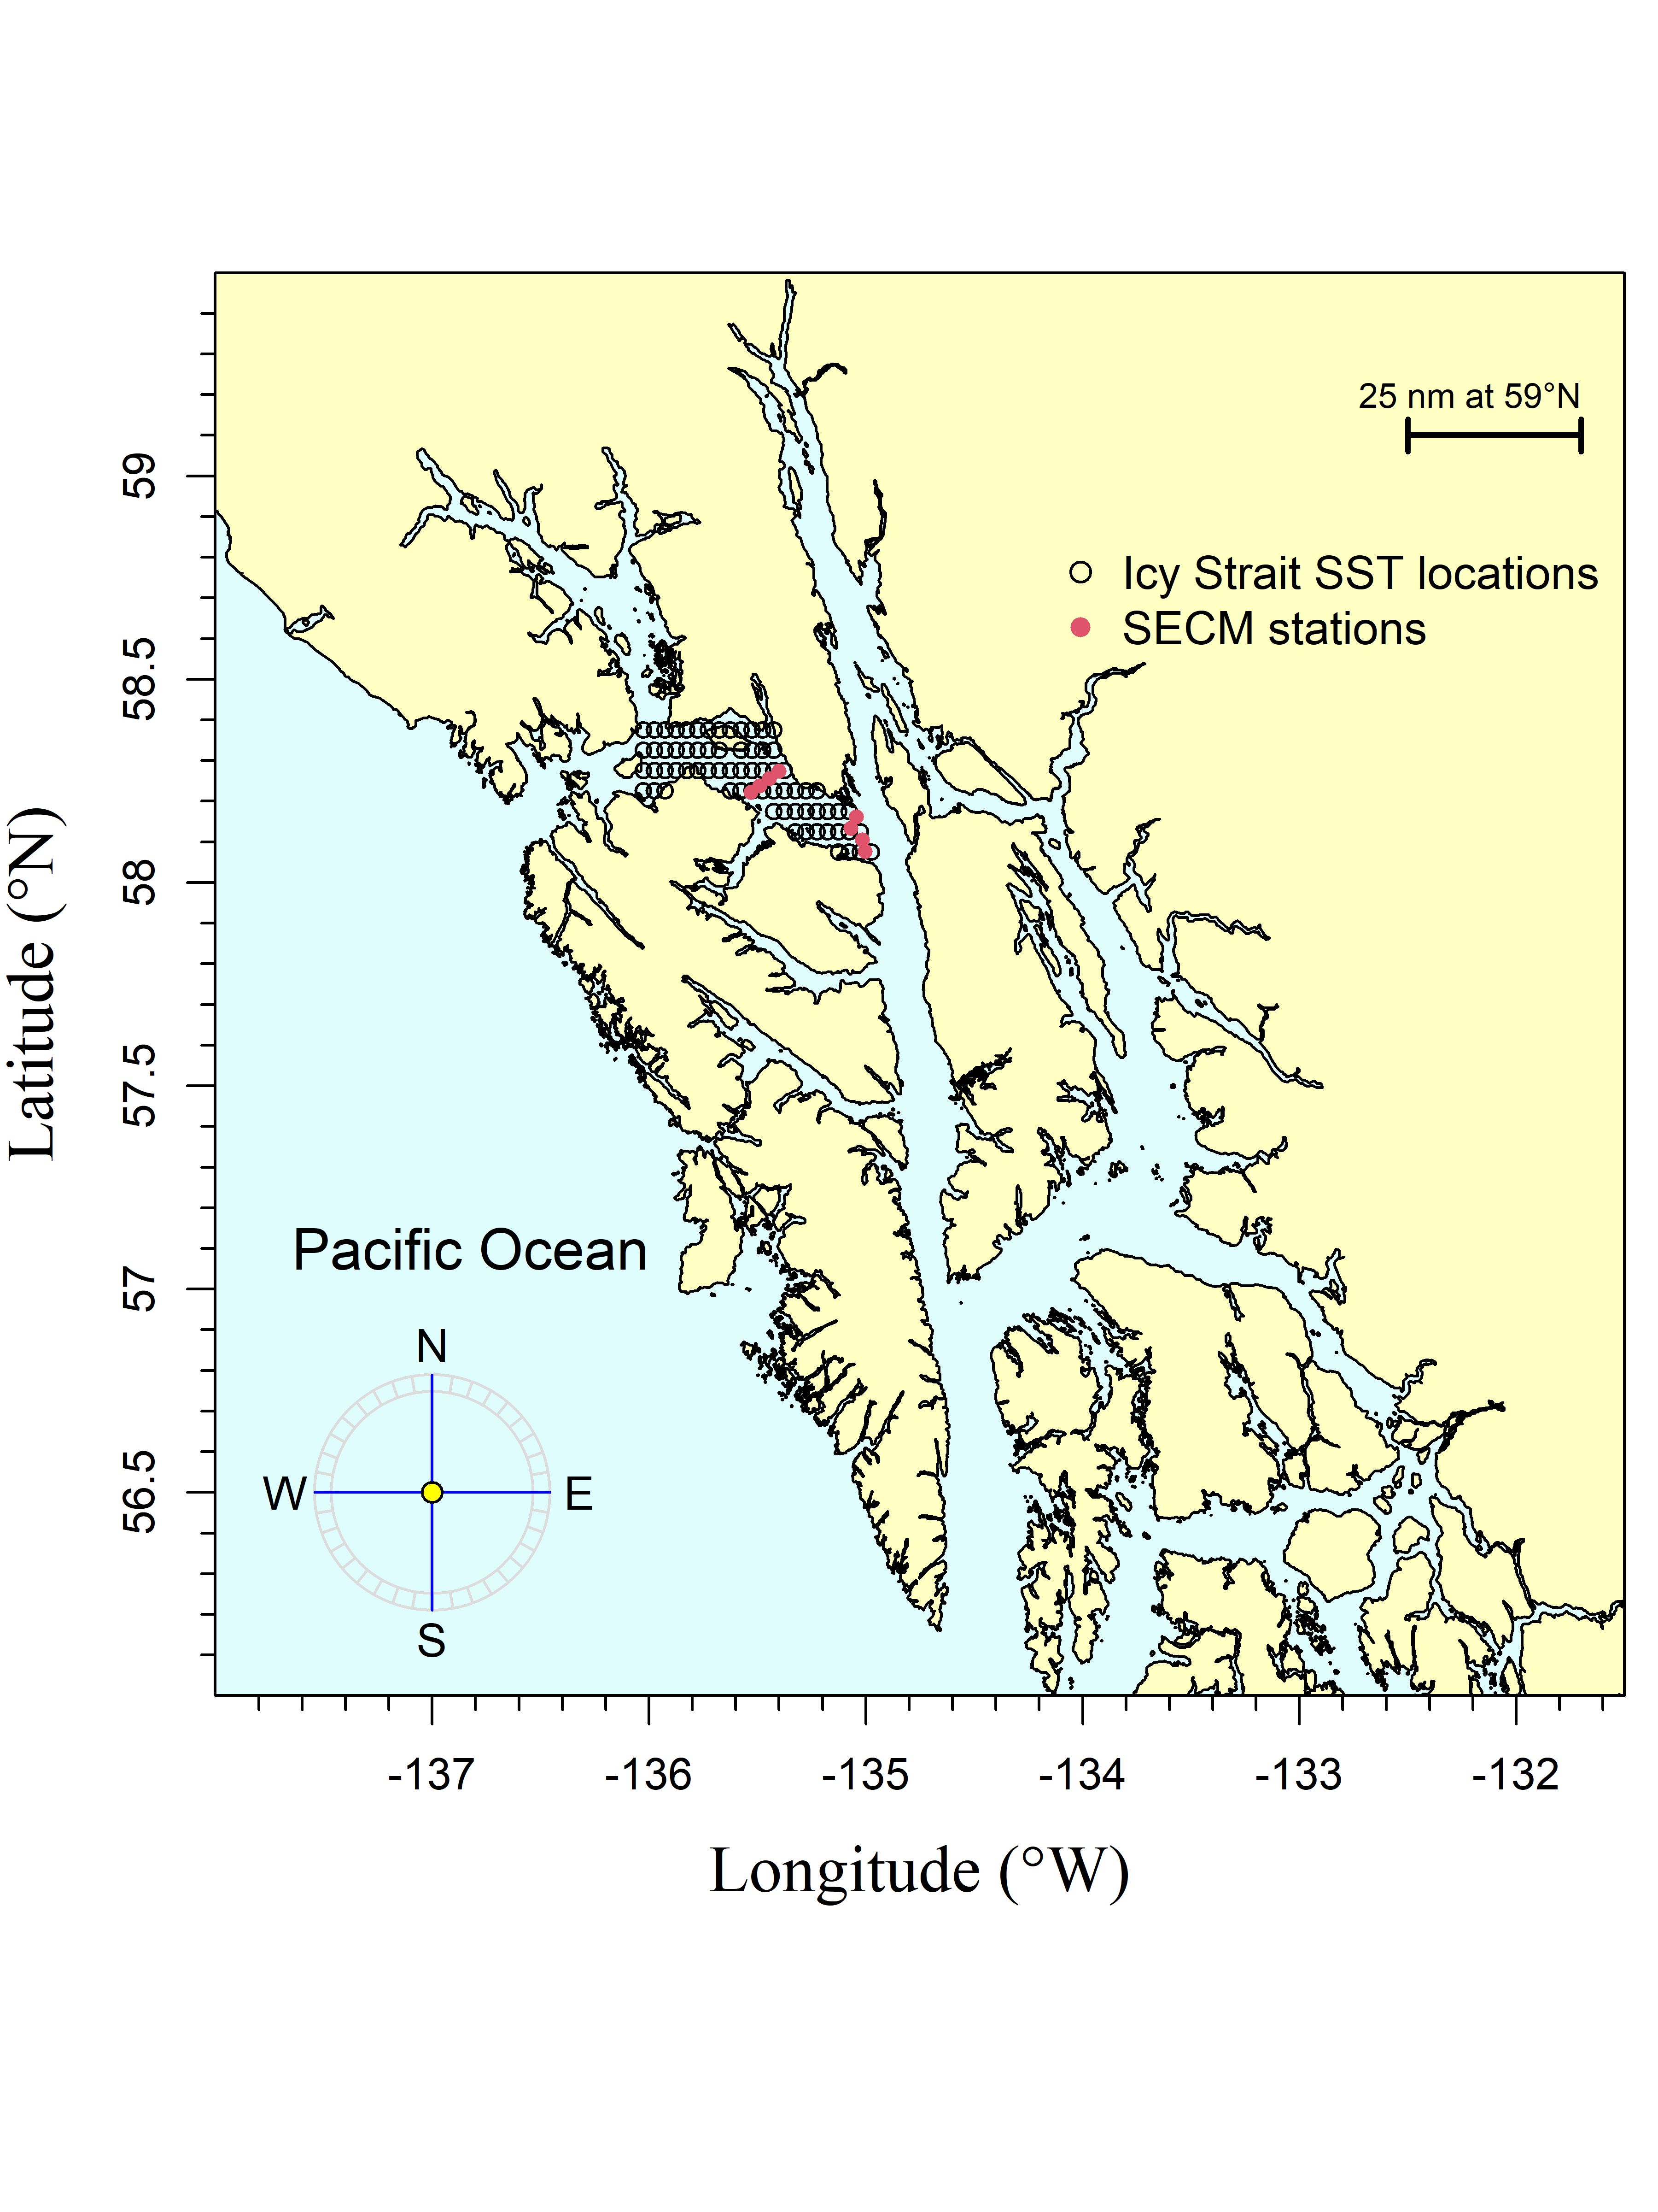

Figure 1.–The Icy Strait region encompasses waters of Icy Strait from the east end of Lemesurier Island to a line from Point Couverden south to Point Augusta. The Southeast Coastal Monitoring (SECM) project transects (Upper Chatham Strait and Icy Strait) are shown as red points for comparison to the satellite stations (i.e., data points; black circles).

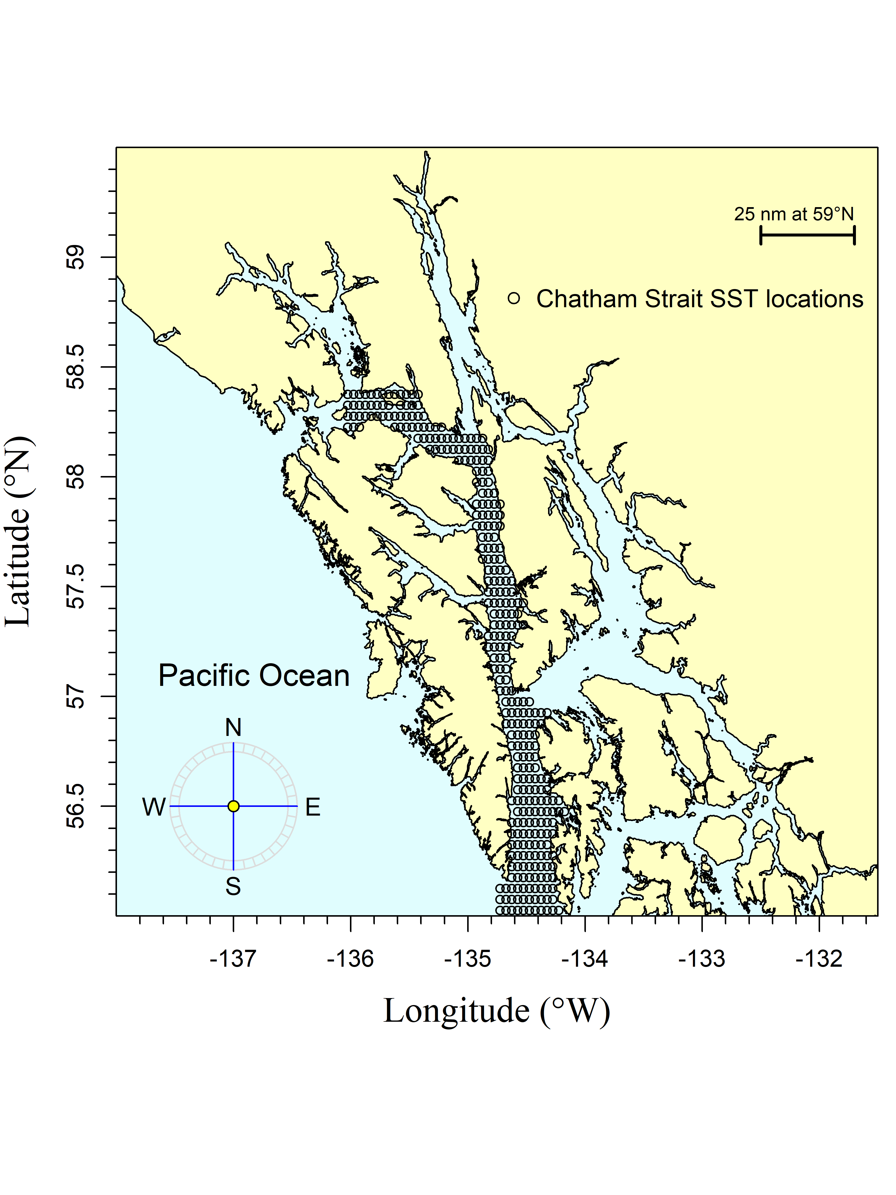

Figure 2.–The Chatham and Icy Straits region encompasses waters of Chatham and Icy Straits east of Lemesurier Island to Point Couverden, south to the approximate latitude of 56.025 degrees north (roughly Cape Decision off Kuiu Island). The black circles are the satellite stations (i.e., data points).

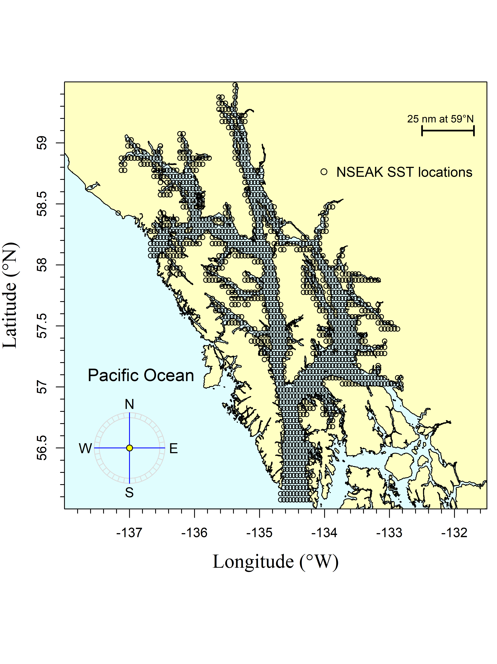

Figure 3.–The northern Southeast Alaska (NSEAK) region encompasses northern Southeast Alaska from 59.475 to 56.075 degrees north latitude and from -137.175 to -132.825 degrees west longitude. The black circles are the satellite stations (i.e., data points).

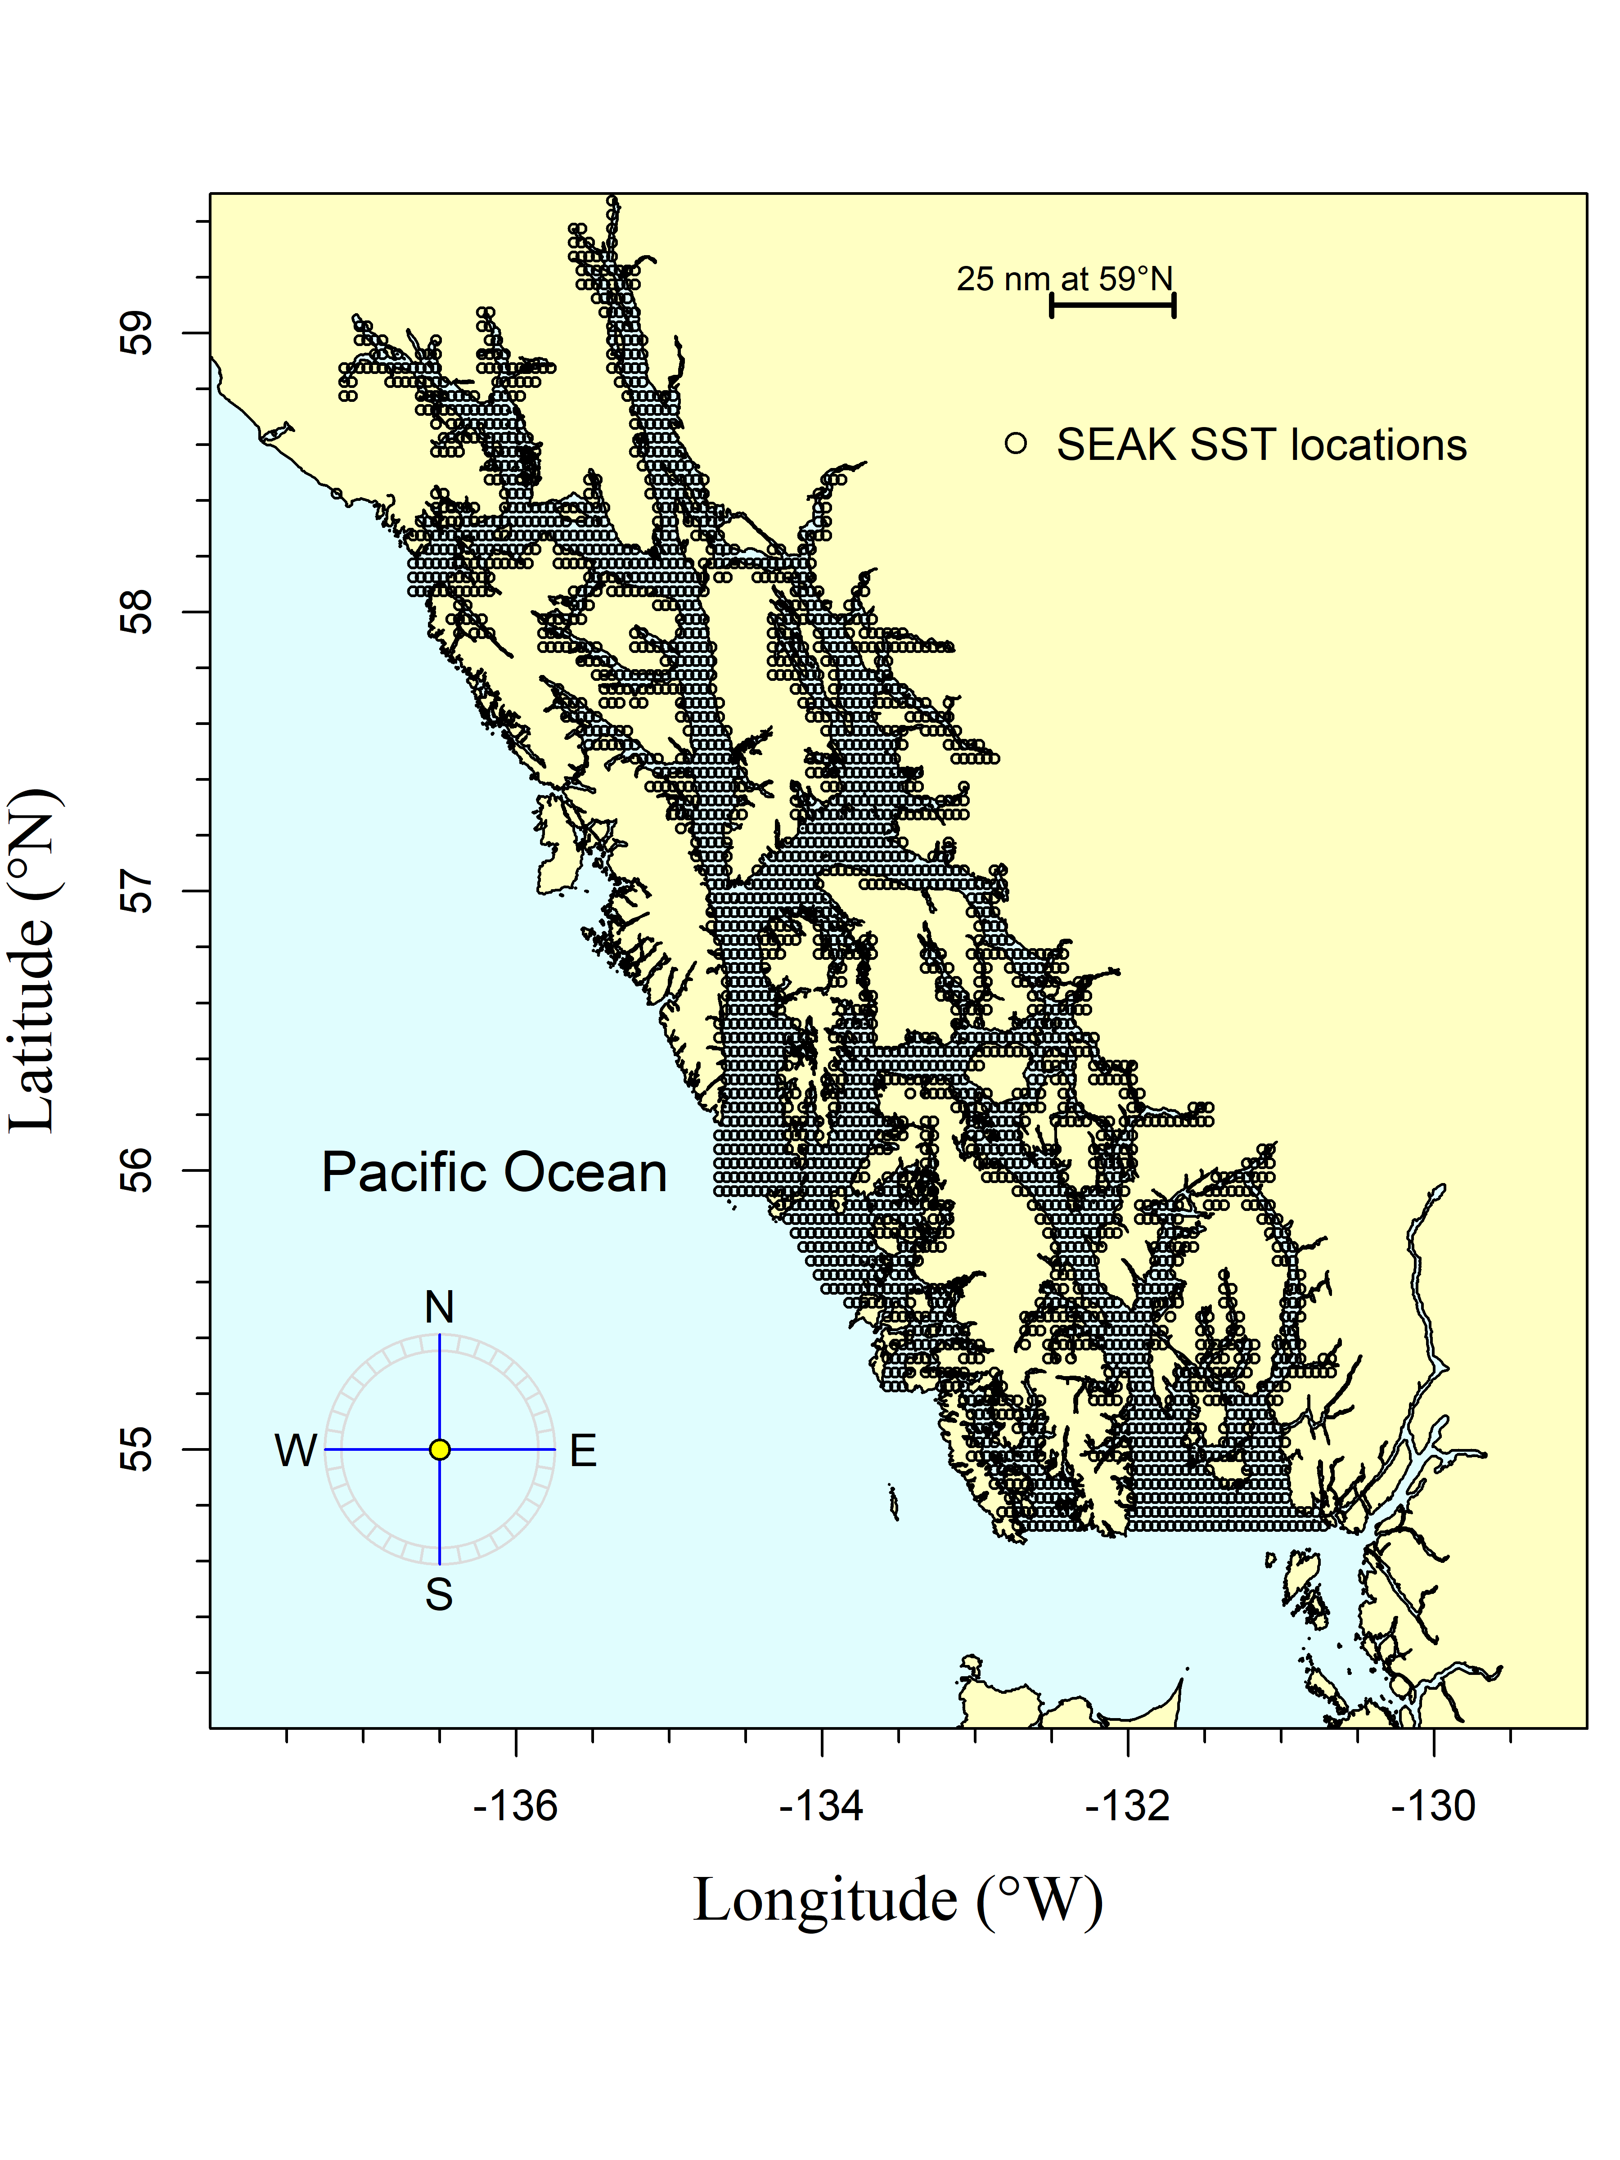

Figure 4.–The Southeast Alaska (SEAK) region encompasses Southeast Alaska from 59.475 to 54.725 degrees north latitude and from -137.175 to -130.675 degrees west longitude. The black circles are the satellite stations (i.e., data points).

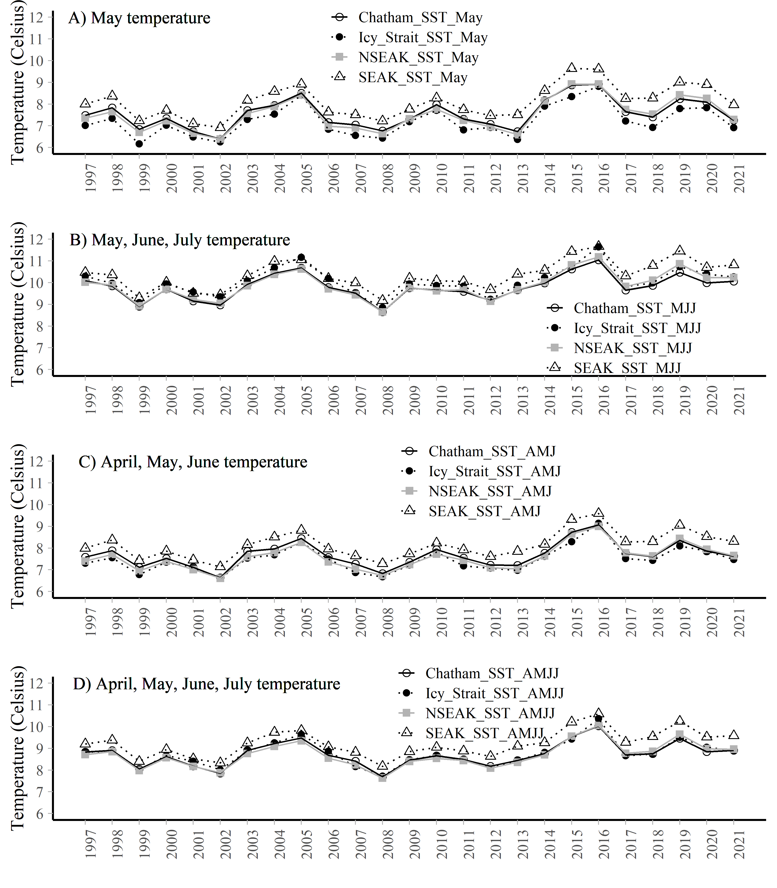

Figure 5.–A. The May temperature averaged over each region (Chatham and Icy Straits, Icy Strait, NSEAK, SEAK) from 1997 through 2021. B. The May, June, and July temperature averaged over each region (Chatham and Icy Straits, Icy Strait, NSEAK, SEAK) from 1997 through 2021. C. The April through June temperature averaged over each region (Chatham and Icy Straits, Icy Strait, NSEAK, SEAK) from 1997 through 2021. D. The April through July temperature averaged over each region (Chatham and Icy Straits, Icy Strait, NSEAK, SEAK) from 1997 through 2021.

## SECM survey temperature data

SECM survey temperature data were summarized by year (1997 to 2021), month (average over the months of May, June, and July) at 20m depths for the Icy Strait and Upper Chatham transects combined.

### SECM survey temperature variables

**ISTI20_MJJ**: Average temperature in the upper 20m during May through July at 8 stations in Icy Strait (Icy Strait and Upper Chatham transects; Figure 1; Figure 6; Table 5).

#### Summarized data

SECM survey temperature data were summarized by year (1997 to 2021), month (average over the months of May, June, and July) at 20m depths; Table 5).

Table 5.–The SECM survey temperature data were summarized by year (1997 to 2021), month (the months of May, June, and July; MJJ) at 20m depths for the Icy Strait and Upper Chatham transects (stations ISA, ISB, ISC, ISD, UCA, UCB, UCC, UCD).

|  |  |
| --- | --- |
| year | ISTI20_MJJ |
| 1997 | 9.275320 |
| 1998 | 9.397513 |
| 1999 | 8.559749 |
| 2000 | 8.770015 |
| 2001 | 9.025533 |
| 2002 | 8.199539 |
| 2003 | 9.307691 |
| 2004 | 9.333084 |
| 2005 | 10.206372 |
| 2006 | 8.750817 |
| 2007 | 8.936006 |
| 2008 | 7.911832 |
| 2009 | 9.356667 |
| 2010 | 9.353333 |
| 2011 | 8.653333 |
| 2012 | 8.476667 |
| 2013 | 8.834667 |
| 2014 | 9.120000 |
| 2015 | 9.606667 |
| 2016 | 10.198500 |
| 2017 | 8.560533 |
| 2018 | 8.924952 |
| 2019 | 9.911211 |
| 2020 | 8.888253 |
| 2021 | 8.885510 |

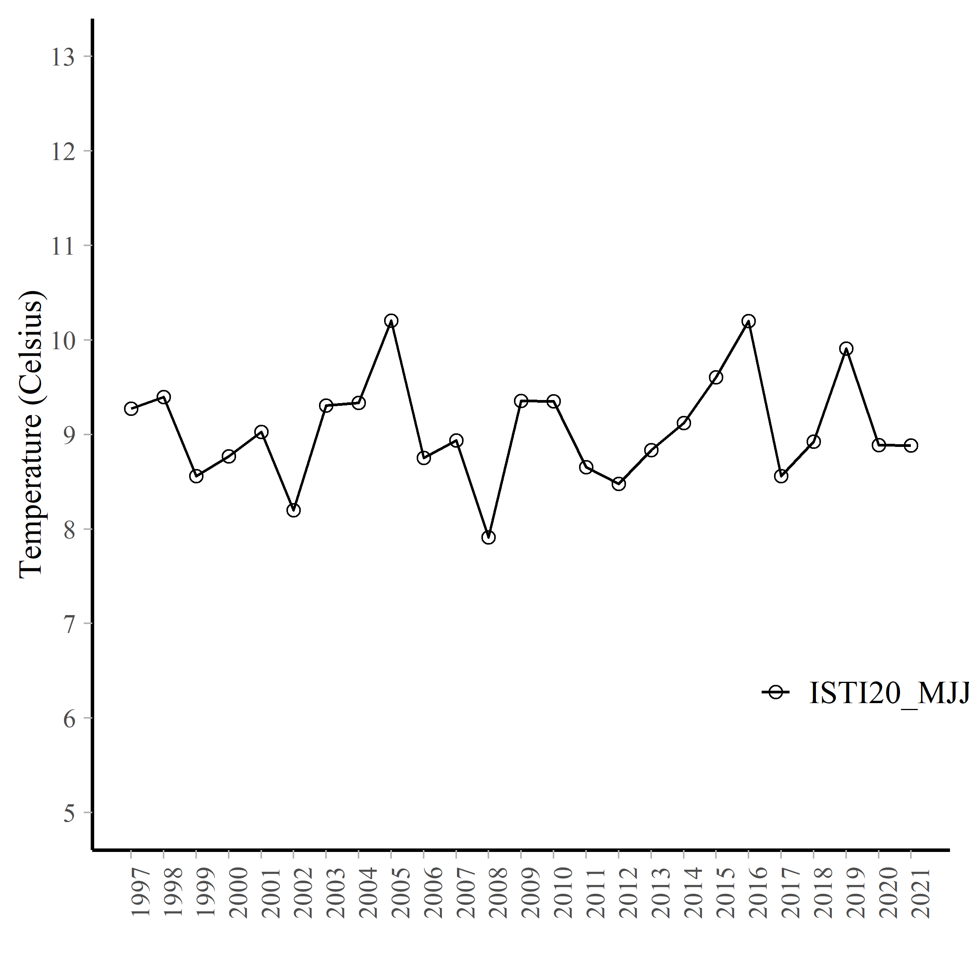

Figure 6.–Average temperature (degrees Celsius) at 20m during May, June, and July at 8 stations in Icy Strait (Icy Strait and Upper Chatham transects; ISTI) from 1997 through 2021.

# References

NOAA Coral Reef Watch (NOAA_DHW_monthly dataset). 2021, updated daily. NOAA Coral Reef Watch Version 3.1 Monthly 5km SST and SST Anomaly, NOAA Global Coral Bleaching Monitoring Time Series Data, May 1997-June 2021. College Park, Maryland, USA: NOAA/NESDIS/STAR Coral Reef Watch program. Data set accessed 2021-10-01 at <https://coastwatch.pfeg.noaa.gov/erddap/griddap/NOAA_DHW_monthly.html>.

NOAA Coral Reef Watch (NOAA_DHW dataset). 2021, updated daily. NOAA Coral Reef Watch Daily Near-real-Time Global 5km SST and SST Anomaly, NOAA Global Coral Bleaching Monitoring Time Series Data, July 2021. College Park, Maryland, USA: NOAA/NESDIS/STAR Coral Reef Watch program. Data set accessed 2021-10-01 at <https://coastwatch.pfeg.noaa.gov/erddap/griddap/NOAA_DHW.html>.

Piston, A. W., J. Murphy, J. Moss, W. Strasburger, S. C. Heinl, E. Fergusson, S. Miller, A. Gray, and C. Waters. 2021. Operational Plan: Southeast coastal monitoring, 2021. ADF&G, Regional Operational Plan No. ROP.CF.1J.2021.02, Douglas.